802.1ag Utils

1.802.1ag run on layer 2 directly with Ethertype 0x8902,

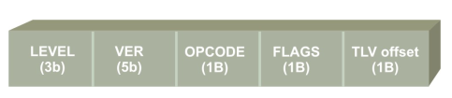
1.for level :
- 0-3 for operator
- 3-4 for provider
- 5-7 for customer
2.Version is supposed to zero
3.Opcode is the indicator which indicates what type of message it is
• 0 reserved
• 1 continuity check message
• 2 loopback reply
• 3 loopback message
• 4 linktrace reply
• 5 linktrace message

4.Flags is used to enable or disable additional feature
5.TLV offset indicates the offset value from which the TLVs start.

